Member function define Inside Class
#include <iostream>
using namespace std;
# include <string.h>
class employee
{
char name [30];
float age;
public :
void insert_data (char * name1, float age1)
{
strcpy (name, name1);
age = age1;
}
void show_data ( )
//displaying the data members
{
cout<<"\nname is"<<name;
cout<<"\nage is"<<age;
}
};
int main ( )
{
employee e1; //first object of class employee
employee e2; //second object of class employee

e1.insert_data("Hemanga",30);
e2.insert_data ("Prakash",32);
cout << "Employee Details:";
e1.show_data ( );
e2.show_data ( );
return 0;
}
OUTPUT


Member Function defined outside class
#include<iostream>
#include<string.h>
using namespace std;
class employee
{
private:
char name [30];
float age;
public:
void insert_data (char *name1, float age1);
void show_data ( );
};
void employee::insert_data (char *name1, float age1)
{
strcpy (name, name1);
age = age1;
}
void employee ::show_data ( ) // Function definition
{
cout <<"\nName is :"<<name;
cout <<"\nAge is:"<<age;
}
int main ( )
{
employee e1, e2;
e1 . insert_data ("Hemanga", 30);
e2 . insert_data ("Prakash", 32);
cout<<“EMPLOYEE DETAILS ... ”;
e1 . show_data ( );
e2 . show_data ( );
return 0;
}
OUTPUT
EMPLOYEE DETAILS ...
Name is :Hemanga
Age is:30
Name is :Prakash
Age is:32

Here in our example, the class ‘employee‘ contains two data members and two member functions.
The member function insert_data( ) is used to assign value to the member variable or data member ‘name’ and ‘age’.
The member function show_data( ) is used to display the values of the data members.
The data member of the class ‘employee’ cannot be accessed by any other functions that are defined outside the class.
It means only the member functions of a class are permitted to access its data members.
In the above program, in main( ) we have declared two objects through the statements employee e1; and employee e2;
The statements e1.insert_data (“Hemanga”, 30); e2.insert_data (“Prakash”, 32); initialize the data members of object e1 and e2.
The object e1’s data member ‘name’ is assigned ‘Hemanga’ and age is assigned 30.
Similarly, the object e2’s data member ‘name’ is assigned ‘Prakash’ and age is assigned 32.
The statements e1.show_data ( ); e2.show_data ( ); call their member show_data ( ) to display the contents of data members namely, ‘name’ and ‘age’ of employee objects e1 and e2.
The two objects e1 and e2 will hold different data values.
In the program we have defined the member functions– void insert_data (char* name1, float age);and void show_data ( ); inside the class ‘employee’.
We have seen that these function definition are similar to the normal function definition except that they are enclosed within the body of a class.
They will be treated as an inline function.
In the above definitions, the label
‘employee : :’
informs the compiler that the functions insert_data ( ) and show_data ( ) are the members of the employee class.
The member functions have some special characteristics.

Array of objects
#include<iostream>
#include<string.h>
using namespace std;
class employee
{
private:
char name [30];
float age;
public:
void insert_data (char *name1, float age1)
{
strcpy (name, name1);
age = age1;
}

void show_data ( )
{
cout<<"\nName:"<<name;
cout<<"\nAge:"<<age;
}

};
int main ( )
{
int i,n, age, count;
char name [30], tag;
employee consultant[30];

cout<<"enter number of employees";
cin>>n;
for (i=0; i<n; i++)
{
cout <<"\n Enter Name of Employee:";
cin >> name;
cout << "Age:";
cin >> age;
consultant[i].insert_data(name, age);
count ++;

}
cout <<"\n\n Employee Details ......\n" ;

for (i=0; i < n; i ++)
consultant[i].show_data();
return 0;
}
OUTPUT


Friend Function
#include<iostream>
using namespace std;
class first ;
class second
{
int x ;
public :
void getvalue ( )
{
cout << "\n Enter a number :" ;
cin >> x ;
}
friend void sum(second, first);//declaration of friend function
} ;
class first
{

int y ;
public :
void getvalue ( )
{
cout << “\n Enter a number:” ;
cin >> y ;
}
friend void sum (second, first) ;
} ;
void sum (second m, first n)
{
cout << "\n Sum of two numbers :" << n.y + m.x ;
}
int main( )
{

first a ;
second b ;
a.getvalue ( ) ;
b.getvalue ( ) ;
sum(b,a);//funciton is called like a general function in C++
return 0;
}
OUTPUT
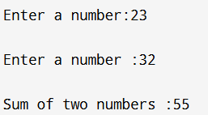

In the above program each of the two classes ‘first’ and ‘second’ has a member function named getvalue ( ) and one private data member. Notice that, the function sum ( ) is declared as friend function in both the class. Hence, this function has the ability to access the members of both the classes. Using sum ( ) function, addition of integers is calculated and displayed. It is possible to declare all the member functions of a class as the friend functions of another class. When all the functions need to access another class in such a situation we can declare an entire class as friend class. Always remember that friendship is not exchangeable. Its meaning is that - declaring class A to be a friend of class B does not mean that class B is also a friend of class A.

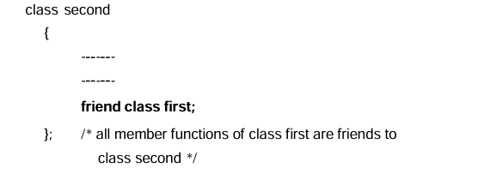
Program
#include<iostream>
using namespace std;
class smallvalue;
class value
{
int a;
int b;
public:
value (int i, int j) // declaration of constructor with

{
a = i;
b = j;
}
friend class smallvalue;
};
class smallvalue
{
public:
int minimum(value x)
{
return x.a < x.b ? x.a : x.b;
}

};
int main ( )
{
value x (15, 25);
smallvalue y;
cout << y. minimum(x);
}

Program (Eg for Constructor)
#include<iostream>
using namespace std;
#define PI 3.1415
class circle
{
private:
float radius;
public:
circle();
void area()
{

cout<<"\nArea of the circle is " ;
cout<<PI*radius*radius<<" sq.units\n";
}
};
circle :: circle() //constructor definition
{
cout<<"\nEnter radius of the circle: ";
cin>>radius;

}
int main()
{
circle c; //constructor invoked automatically
c.area();
return 0;
}
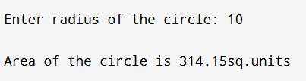
In the above program, the constructor circle( ) takes the value of radius from the keyboard. Although the data member is private, the constructor could initialize them. The statement circle c declares a variable c as object of (type) class circle. It also calls the constructor implicitly.

Progeram(Default)
#include<iostream>
using namespace std;
#define PI 3.1415
class circle
{
private:
float radius;
public:

void area()
{

cout<<"\nArea of the circle is " ;
cout<<PI*radius*radius<<" sq.units\n";
}

circle() //constructor definition
{
cout<<"\nEnter radius of the circle: ";
cin>>radius;

}
};
int main()
{
circle c; //constructor invoked automatically
c.area();
return 0;
}

Output
Enter radius of the circle: 12

Area of the circle is 452.376 sq.units

Program(Parameterized Constructor)
#include<iostream>
using namespace std;
class student
{
private:
int roll,age, marks;
public:
student(int r,int m,int a); //parameterized constructor
void display( )
{
cout<<"\nRoll number"<<roll;
cout<<"\nTotal marks"<<marks;
cout<<"\nAge:"<<age;
}
};
student::student(int r, int m, int a) //constructor definition
{
roll = r;
marks =m;
age=a;
}
int main( )
{

student manoj(5,430,16); //object creation
cout<<"\nData of student 1 : ";
manoj.display();
student rahul = student(6,380,15); //object creation
cout<<"\n\nData of student 2 :";
rahul.display();
return 0;
}

a parameterized constructor with two arguments. In the main( ) function, we see that there are two objects, manoj and rahul of class type student. The object manoj is initialized with the values 5,430 and16 with the implicit call statement student manoj(5, 430,16);. The object rahul is initialized with the values 6,380 and 15 with the explicit call statement student rahul = student(6, 380,15); This statement creates a student object rahul and passes the values 6, 380 and 15 to it.

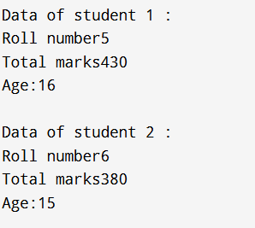

Constructors with Default Arguments
It is possible to have a constructor with arguments having default values. It means that if we have a parameterized constructor with n parameters, then we can invoke it with less than n parameters speci- fied in the call. It is useful when most of the objects to be created are likely to have the same value for some data members. We need not specify that in every invocation. For example, suppose we want to record the data of class x (ten) students. For this, we can consider the same class student as shown in Program 8.2. Most of the students are of age 16. Hence, their birth year is likely to be the same. Only a few of them may have a different year of birth. For this we can use the statement student(int r, int m, int a=16); where the third parameter is given the default value. When we write the following statement student s(1,360); it assigns the values 1 and 360 to the argument r and m respectively and 16 to the argument a by default. Again, if we write student t(2,400,15); it assigns 2, 400 and 15 to r, m and a respectively. Thus, the actual arguments, when specified, overrides the default values.

Copy Constructors
Object of the same class cannot be passed as argument to con- structor to that class by value method.

But it is possible to pass an object of the same class as argument to a constructor by reference method. Such type of constructor, i.e., a constructor having parameter which is a reference to object of the same class is called a copy constructor. Thus, the following dec- laration is a valid declaration.
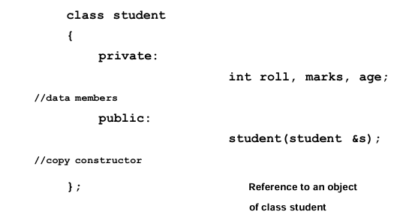
Copy constructor is also called one argument constructor as it takes only one argument. The main use of copy constructor is to initialize the objects while in creation, also used to copy an object. This constructor allows the programmer to create a new object from an existing one by initialization. Let us demostrate copy constructor with the following program :.

Program (Copy Constructor)
#include<iostream>
using namespace std;
class student
{
private:
int roll, marks, age;
public:
student(int r,int m,int a) // parameterized constructor
{
roll = r;
marks = m;
age = a;
}
student(student &s) //copy constructor
{
roll = s.roll;
marks = s.marks;
age=s.age;
}
void display( )
{
cout<<"\nRoll number :" <<roll;
cout<<"\nTotal marks :"<<marks;
cout<<"\nAge:"<<age;
}
};
int main( )
{

student t(3,350,17); // or student k(t);
student k = t; // invokes copy constructor
cout<<"\nData of student t:";
t.display();
cout<<"\n\nData of student k:";
k.display();
return 0;
}
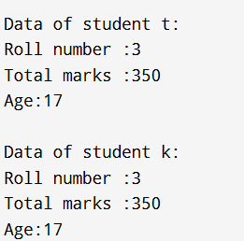

The statements parameterized constructor constructor student t(3,350,17);
Invokes parameterized constructor and student k = t; invokes copy constructor.initialize one object k with another object t. The data members of t are copied member by member into k. When we see the output of the program we observe that the data of both the objects t and k are same.

DESTRUCTORS
Like constructors, destructors are also special member functions used in C++ programming language. Destructors have the opposite function of a constructor. The main function of destructors is to free memory and to release resources. Destructors take the same name as that of the class name preceded by a tilde ~. A destructor takes no arguments and has no return type.The general syntax of a destructor is as follows:
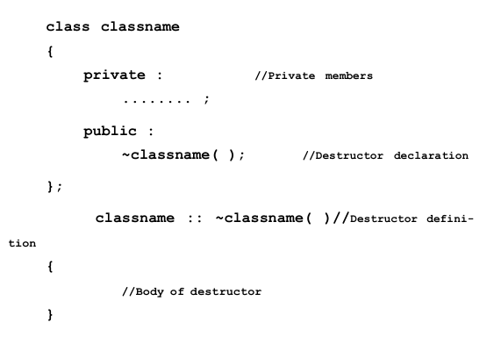
In the above, the symbol tilde ~ represents a destructor which precedes the name of the class. Like the default constructor, the compiler always creates a default destructor if we donot create one. Similar to constructors, a destructor must be declared in the public section of a class. Destructor cannot be overloaded i.e., a class cannot have more than one destructor.

#include<iostream>
using namespace std;
#include<string.h>
class student
{
private:
int age;
char name[25];
public:
student(int a, char n[25])
{
age=a;
strcpy(name,n);
}
void show()
{
cout<<"\nThe name of the student is: "<<name;

cout<<"\nHis age is:"<<age;
}

~student() //destructor defined
{
cout<<"\nObject Destroyed";
}
};
int main()
{
student s1(21,"Rahul");
student s2(23,"Dipankar");

s1.show();
s2.show();
return 0;
}
